User Needs, Benchmarking, and Requirements

# Voice of the Customer Benchmarking

## Search #1

## Product #1

### Keywords: Weather Station Search Result link: <https://www.amazon.com/s?k=weather+station&crid=1JA01T724WXJJ>

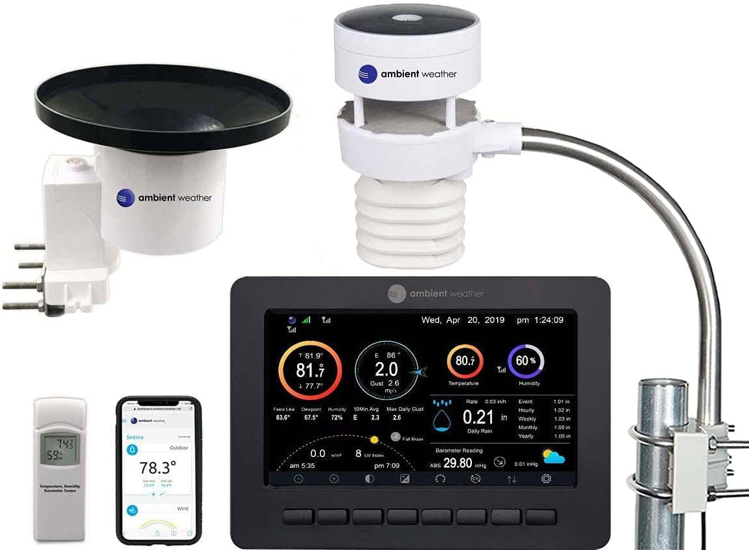

* Price: $449.99
* Vendor:Amazon
* Description: WS-5000 Smart Weather Station, Solar powered and features a Barometer and Hygrometer with optional additions.

### Positive

1. The reviewer needed a reliable replacement for another weather station. The reviewer likes that the device is easy to set up. The reviewer also likes that the device can be placed to avoid obstacles. The reviewer likes that the display is intuitive and setting up data transfer is easy.
   1. The device is easy to set up. (Explicit)
   2. The device is accurate. (Explicit)
   3. The device is portable (Explicit)
   4. The device stores data for easy access (Latent)
2. The reviewer replaced their functional but outdated Davis Weather Monitor II with the Ambient WS-5000 weather station; they experienced no issues after 4 days of use. Setting up the station involved entering latitude/longitude for sunrise/sunset, configuring Wi-Fi, creating an Ambient Weather account, and inputting the MAC address. The station offered accurate data with detailed graphs, while the console's display was bright initially but was adjusted to dim at night. The cost-effective unit provided improved features over the old Davis model, breaking down rainfall data and avoiding data upload charges.
   1. The device input is customizable. (Explicit)
   2. The device is cost effective (Explicit)
   3. The device represent data in a detailed and orderly manner (Explicit)
3. The reviewer bought the Ambient WS-5000 weather station 1.5 years ago, impressed by its high quality compared to their previous weather devices. They appreciated the accuracy of the rain gauge, although it requires occasional cleaning due to debris. They use rechargeable Lithium batteries for extended battery life. The customer found the mobile app useful for remote weather monitoring and mentioned the option to join a large weather network. They advised careful placement of the station due to potential impact on wind and rain readings, and overall, they expressed satisfaction with their purchase decision based on their research.
   1. The device has a long battery life (Explicit)
   2. The device can be easily customized with new parts/sensors (Explicit)
   3. The device requires occasional cleaning (Explicit)

### Negative

1. The reviewer thinks the overall unit is a good unit. They believe it is expensive and cheaply made. The screen is far too small to see most of the information from more than a few feet away. Also the screen breaks with a minor drop (18 inches for me). Out over two hundred dollars to replace.
   1. The device should be made with durable materials (Explicit)
   2. The device should have ample display capabilities (Explicit)
   3. The device should have lower replacement cost (Latent)
2. The customer expresses significant disappointment with their recent purchase of the WS5000 weather station. They found the assembly process to be challenging and not as straightforward as indicated in the video guide. They regret not choosing the $300 unit that permits mounting all components on a single pole for better quality and simplicity. Compared to their previous Davis station's 10-year lifespan, they express further concern as the sensor hangs below the hydrometer, indicating potential issues with design and durability.
   1. The device should be easy to assemble (Explicit)
   2. The device should be safe to use (Explicit)
3. The reviewer's initial enthusiasm for the WS5000 weather station faded when they switched to Starlink internet and the station failed to connect. Despite seeking help from Ambient tech support, they were informed that the station doesn't support Starlink or 5G and the company appeared indifferent to this limitation. The inability to access data online or remotely monitor their RV's temperature due to the lack of internet connectivity disappointed the customer. They also criticize the station's setup process and outdated menu system, concluding that while the station itself is good, the poor setup experience and lack of support for emerging technologies like Starlink and 5G make it a less attractive option, especially for those who value internet connectivity.
   1. The device should have good network connectivity (Latent)
   2. The device should have an intuitive user interface (Explicit)

## Search #2

## Product #2

### Keywords: Rain Gauge Search Result link: [Link](https://www.amazon.com/AcuRite-00899-Wireless-Self-Emptying-Collector/dp/B004V1XJW0/ref=sr_1_7?crid=1MD1VZST8N2G6&keywords=rain+gauge&qid=1693076662&sprefix=rain+guage%2Caps%2C167&sr=8-7)

### Selected Product: AcuRite Wireless Digital Rain Gauge with Self-Emptying Collector with Rainfall History, Alerts, and Current Date and Time (00899), Multicolor

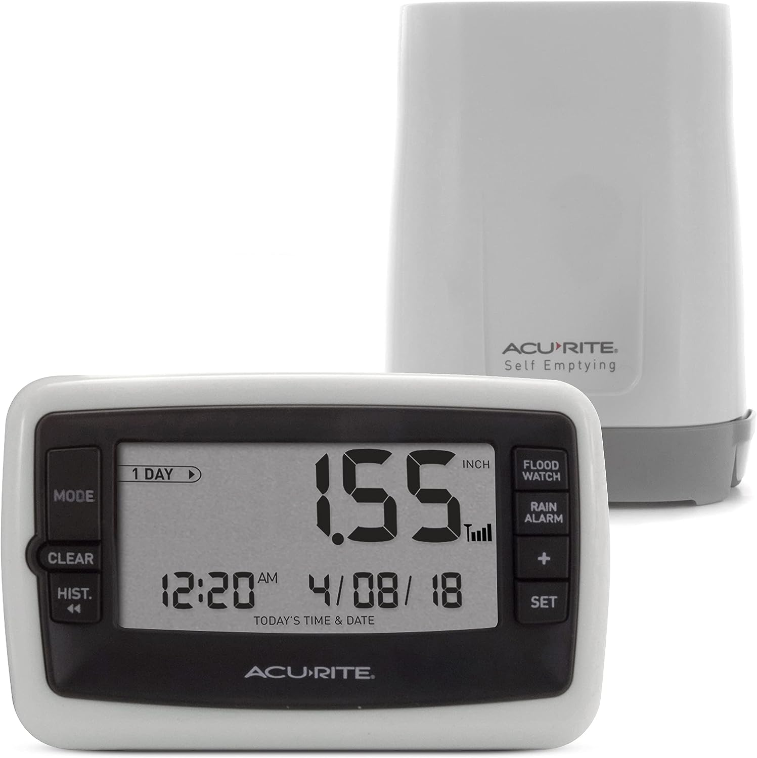

* Price: $37.76
* Vendor:Amazon
* Description: The AcuRite Digital Rain Gauge with Self-Emptying Wireless Rain Collector features precise, reliable rainfall measurements. The LCD screen displays daily rainfall and records rainfall history, including a rainfall event, 1 day or 7 days of measurements. Includes rain and flood watch alarms. The outdoor sensor is self-emptying and transmits rain data wirelessly. Includes a clock and calendar. Display stands upright for tabletop use or is wall-mountable.

### Positive

1. The reviewer is very satisfied with the rain gauge and believes it is better than any other they have used before. They love that it is self-emptying, which saves them time and hassle.They also appreciate that it stores 7 days of data, which allows them to track rainfall patterns over time.The reviewer says that the rain gauge has helped them save money on watering their lawn.They also mention that the rain gauge was easy to set up.
   1. The device is a time saver. (Latent)
   2. The device is easy to set up. (Explicit)
   3. The device saves the user money. (Explicit)
2. The reviewer is very happy with the rain gauge and loves that it empties itself, tracks daily rain amount, and stores history of rain amount. They also appreciate the accuracy of the rain gauge and find it fun to see the totals adding up each time it rains.
   1. The device can empty itself.(Explicit)
   2. The device provides accurate measurements. (Explicit)
   3. The device is engaging to its user. (Latent)
3. The reviewer is very happy with the AcuRite Wireless Digital Rain Gauge and finds it to be accurate. They have compared the readings from the rain gauge to the readings from their weather station and found that they are within 1/100th to no more/less than 1/10th of each other. The reviewer likes that the rain gauge allows them to know how much rain they have received, rather than relying on regional totals from the news. They have found that the rain gauge is especially helpful in areas where rainfall can vary greatly from place to place.
   1. The device provides accurate measurements. (Explicit)
   2. The device allows the user to be more independent. (Latent)
   3. The device provides consistent measurements. (Explicit)

### 

### 

### 

### Negative

1. The reviewer purchased a rain gauge and set it up according to the manual. However, the rain gauge did not measure the rainfall correctly. The reviewer used a manual rain gauge to measure the rainfall and it showed that 2.5 inches of rain had fallen. However, the digital rain gauge only registered less than 0.05 inches of rain.
   1. The device provides accurate measurements. (Explicit)
   2. The device’s manual needs to be user friendly. (Latent)
   3. The device is easy to set up. (Explicit)
2. The reviewer purchased a wireless rain gauge and has been using it for about a month. However, the rain gauge has lost signal multiple times. The reviewer has placed the receiver in the window closest to the collector, which is about 20 feet away. Even with the receiver closer to the collector, the rain gauge still loses signal.
   1. The device needs to have a strong wireless connection. (Explicit)
   2. The device needs to be more reliable. (Latent)
   3. The device’s accessories need to be as robust as the main device. (Latent)
3. The pairing process was difficult and took several tries. If the batteries are bumped, the system resets and has to be set up again. The readings from the rain gauge are inaccurate.
   1. The device is easy to set up. (Explicit)
   2. The device needs to be rugged enough for extended outdoor use. (Latent)
   3. The device's software needs to be intuitive/stress-free. (Latent)

## Product #3 Search Result link: [Link](https://www.amazon.com/Logia-Monitoring-Temperature-Humidity-Direction/dp/B09QFZTBMG/ref=asc_df_B09QFZTBMG/?tag=hyprod-20&linkCode=df0&hvadid=563573121555&hvpos=&hvnetw=g&hvrand=1766087343685672365&hvpone=&hvptwo=&hvqmt=&hvdev=c&hvdvcmdl=&hvlocint=&hvlocphy=9030039&hvtargid=pla-1600608544258&psc=1)

### Selected Product:Logia 7-in-1 Weather Station Indoor/Outdoor Weather Monitoring System, Temperature Humidity Wind Speed/Direction Rain UV & More, Wireless Color Console w/Forecast Data, Alarm, Alerts

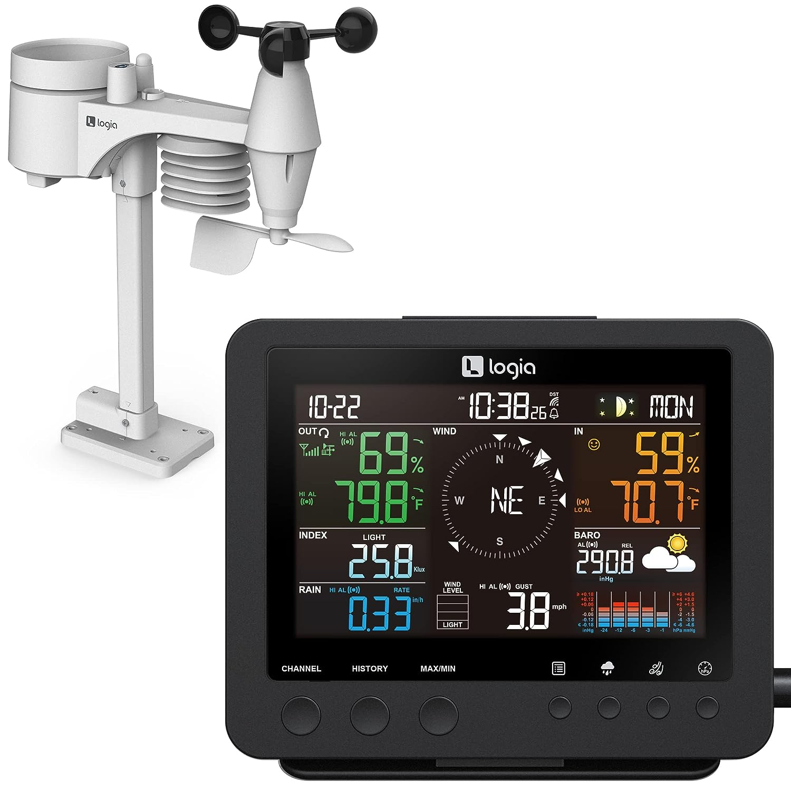

* Price: $99.99
* Vendor:Amazon
* Description:This unit tracks indoor/outdoor humidity and temperature; wind speed and direction; current rainfall and rate; UV and solar intensity and a host of other weather-related details.

### Positive

1. The reviewer purchased a wireless weather station and is generally happy with it. The display is nicely made, but it is too small for the reviewer's desired location. The weather station is supposed to receive a time signal, but it has never happened. The reviewer had to set the clock manually. The weather station is accurate and the outside piece is compact.
   1. The device needs to have an easy to read display. (Explicit)
   2. The device's software needs to be intuitive/stress-free. (Latent)
   3. The device's physical appearance should be inoffensive. (Latent)
2. The reviewer purchased a wireless weather station and is using it to monitor the weather conditions outside their home. They had no trouble connecting the station with the base unit and there have been no connectivity issues with a 50-60 foot separation. The reviewer believes the weather station to be accurate and responsive to changing conditions.
   1. The device needs to have a strong wireless connection. (Explicit)
   2. The device provides multiple measurements of weather conditions. (Explicit)
   3. The device provides accurate measurements. (Explicit)
3. “It is brilliant I'm a 12 year old boy who wants to become a meteorologist and this is the perfect gift thank you”
   1. The device can be used by a large demographic. (Latent)
   2. The device's software needs to be intuitive/stress-free. (Latent)
   3. The device is easy to set up. (Explicit)

### Negative

1. The reviewer purchased a wireless weather station and is not happy with it. The weather station is constantly losing signal and it is not easy to get it to pair up again. The outdoor unit also shows half battery after only a few weeks, even with Duracell batteries. The reviewer does not recommend buying this weather station as it is not reliable.
   1. The device needs to have a strong wireless connection. (Explicit)
   2. The device needs to be efficient. (Explicit)
   3. The device is easy to set up. (Explicit)
2. The reviewer purchased a weather station and it worked as intended for the first 35 days. However, after 35 days, the weather station stopped working. The reviewer tried to reset the unit but the reset light would not come on. The reviewer checked the batteries and they were good, and they even replaced the batteries but the weather station still did not work. The reviewer would not recommend this product.
   1. The device needs to be rugged enough for extended outdoor use. (Latent)
   2. The device's software needs to be intuitive/stress-free. (Latent)
   3. The device needs a complementary troubleshoot guide. (Explicit)
3. The reviewer ordered a weather station and the display would flicker. They returned it for a new one but the display was worse. The reviewer could not see the display at all and they returned it.
   1. The device needs an easy to read display. (Explicit)
   2. The device needs to be rugged enough for extended outdoor use. (Latent)
   3. The device needs a complementary troubleshoot guide. (Explicit)

## Product #4

### Keywords: Weather Station Search Result link: [Link](https://www.amazon.com/Tempest-Weather-Accurate-Forecasts-Wireless/dp/B0868WY7NY/ref=sr_1_28?crid=1JA01T724WXJJ&keywords=weather+station&qid=1693183443&sr=8-28)

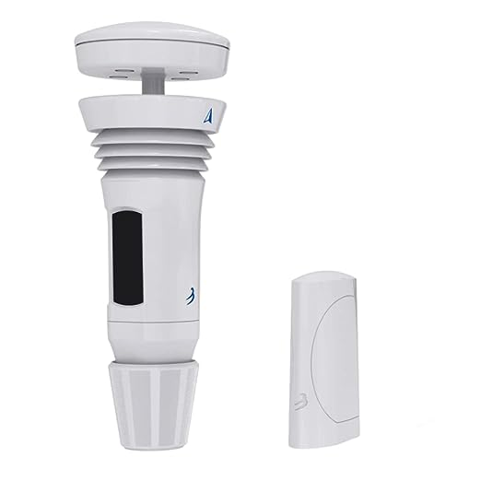

* Price: 339.00
* Vendor:Amazon
* Description: Tempest Weather System with Built-in Wind Meter, Rain Gauge, and Accurate Weather Forecasts, Wireless, App and Alexa Enabled

### Positive

1. The reviewer was impressed with the product and researched many other products before choosing this product. The product withstand temperatures over 110 degrees and works with no problems. The accuracy of the forecast is more accurate than the National Weather Service for local weather.
   1. Need hardware for mounting the product.
   2. Need to come in different colors to match the environment.
2. Reviewer had a problem with the Tempest when a humidity sensor was faulty. Tech support was very helpful and sent a replacement within 3 days. Even with the faulty product reviewer still recommends product and values tech support.
   1. Need a way to run self-diagnostics to find problems.
   2. Need to be tested before leaving the factory.
3. Reviewer was impressed with the ease of setup and it was hard to mess up. Reviewer was skeptical of the forecast till it was proven true. Lastly the rain accuracy was spot on compared to the last unit(different brand) owned.
   1. Need rain and wind direction sensor.
   2. Need to last a few years.

### Negative

1. Reviewer had trouble with the unit, data was random and off in measuring. Tired calling tech support but got no answer and could not get the unit working right. Wrote an app to display temperature and sensor was off by 3 degrees.
   1. Need better tech support for answers and solutions.
   2. Need sensors to work properly.
2. Reviewer had it in operation for 18 months but it was unreliable. The accumulative rain was the first problem, it would read randomly. The wind speed feature was the next problem.
   1. Need accumulation of rain to work.
   2. Need a unit to read wind speed accurately.
3. Reviewer said the product was extremely inaccurate. The wind speed was wrong and direction was wrong also. The rain sensor would read outside with no rain. The only slightly right was the temperature sensor but still a few degrees off.
   1. Need sensors to work properly.
   2. Need a year warranty.

## Product #5

### Keywords: Rain gauge

### Search Result link: [Link](https://ambientweather.com/ws-1900-solar-powered-wireless-professional-weather-station?utm_id=go_cmp-17798158262_adg-_ad-__dev-c_ext-_prd-WS-1900A_mca-147779820_sig-Cj0KCQjwi7GnBhDXARIsAFLvH4m91Se60tjqam6j6u5-a1KuIV1FKFvNRIh6hEjVom5tGr16vpe6BvkaAn2ZEALw_wcB&utm_source=google)

* Price: 119.19
* Vendor: Ambient Weather
* Description:

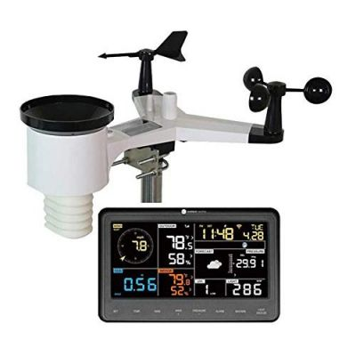

### Positive

1. The unit works impressively as expected. I’m still learning its capabilities & limitations. For example, I’m wondering how long the wind gust data are retain: 1 min., an hr, …? Peak gust speed in the 24 hrs?
   1. Show different statistics (Latent)
   2. Have a lot of options (Explicit)
2. Works! Not too difficult to install. Colors on the monitor are a bit much. Dark background with white numbers would have been fine for me.Would like more options for temp min and max. Ex min & max for 24 hours, a week, a month, a year.
   1. Have a large temperature range (Explicit)
   2. Work on power for a week (Latent)

### Negative

1. I found the backlight in the indoor display could be brighter.
   1. Bright backlight (Explicit)
   2. Light around screen (Latent)
2. If you are not looking almost straight on to it, the information disappears from view until you move back on-axis. This is a common problem for this type of screen, but it's still unfortunate.
   1. Screen visible from multiple directions (Explicit)
   2. Easy to use screen type (Explicit)
3. I only wish it didn’t need to be plugged in for the display to stay on. Pretty hard to find the button in the dark. I’d rather change batteries with it staying on than having the cord running down to a plug.
   1. Battery powered (Explicit)
   2. Light up controls (Latent)

# Organize

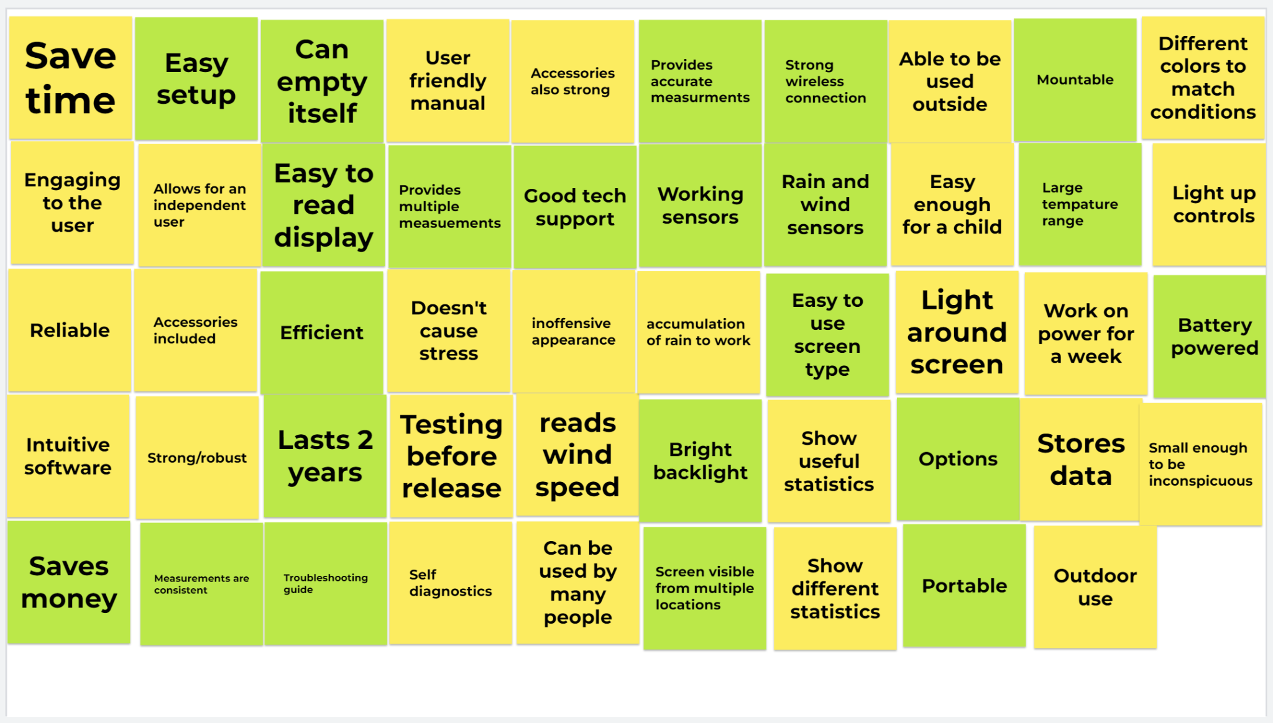

Figure 1: Jamborad full of needs created (Green for explicit, yellow for latent) ([LINK](https://jamboard.google.com/d/1A8twxdgbhuXQK7pF-5-EECv7ibeArtA6bo-eUjhiVNA/edit?usp=sharing))

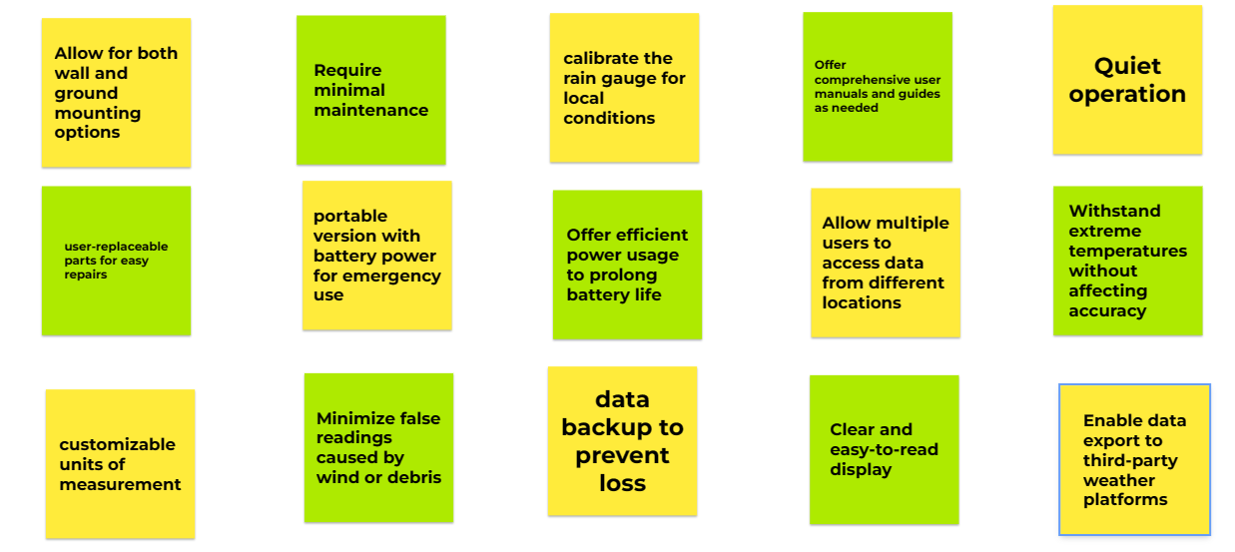

Figure 2: Jamborad full of needs created (Green for explicit, yellow for latent)

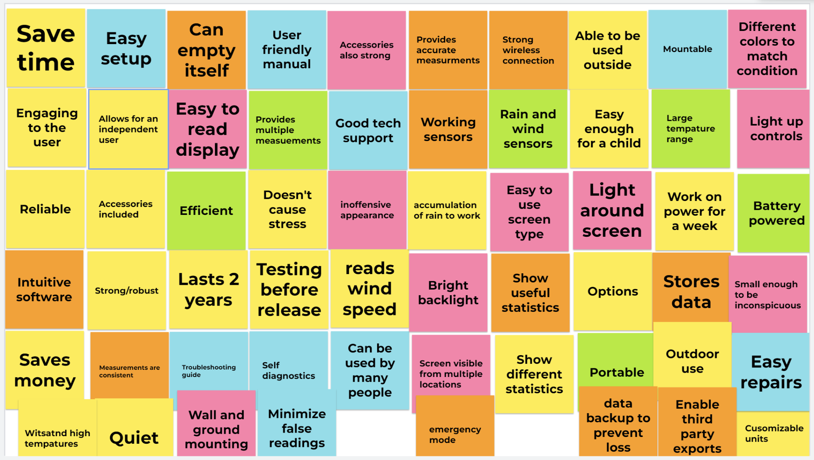

Figure 3: Categorized Jamborad (Blue for diagnostics, pink for appearance, orange for software, and yellow and green for user desires with green being a class requirement)

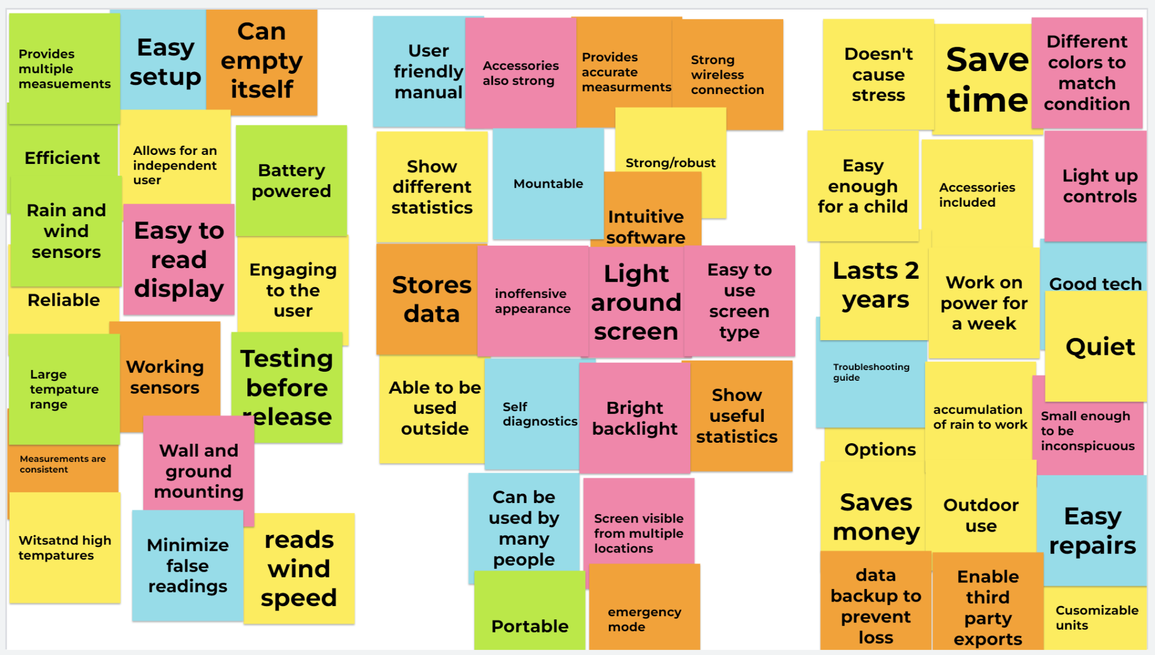

Figure 4: Ranked jamborad (3 star to the right, 2 star in the middle, 1 star to the left)

Ordered Needs:

1. The device has automated systems
2. The device makes accurate measurements
3. The device includes wireless connectivity
4. The device is made from rugged material
5. The device is reliable
6. The device is easy to set up
7. The device is a time saver
8. The device has the ability to save the user money
9. The device takes consistent measurements
10. The device has an attractive design
11. The drive can be manufactured in multiple colors and finishes
12. The device is designed for longevity
13. The device can be portable
14. The device is calibrated from the factory
15. The device can be calibrated by the user
16. The device uses renewable energy for its power consumption
17. The device is designed with an expandable ecosystem in mind
18. The device is efficient with its power use
19. The device has easy to read measurements
20. The device caters to a large demographic
21. The device incorporates an inoffensive design
22. The device can be mounted to existing hardware
23. The device can store data in the cloud
24. The device can store data on local storage solutions
25. The device can measure multiple points of weather data
26. The device provides a strong wireless connection
27. The device can measure wide intervals of data
28. The device can withstand high speed winds
29. The device can withstand prolonged exposure to UV rays without discoloration
30. The device can withstand extreme heat and cold temperatures
31. The device allows the user to be self-sufficient/independent
32. The device’s screen can be viewed from multiple angles
33. The device’s display is backlit
34. The device’s display has touch capacity
35. The device can self-diagnose for problems
36. The deuce can empty its data collection tube autonomously
37. The device has a standby mode
38. The device has intuitive software
39. The device can be serviced by the user
40. The device will include enough accessories for use out the box
41. The device can be used by multiple users
42. The device will come with a troubleshooting guide
43. The device can be engaged with remotely
44. The device will come with a user friendly manual
45. The device’s battery life will be substantial
46. The device will be as small as comfortably possible
47. The device will feature physical hardware buttons
48. The device can be operated completely remotely
49. The device will maintain a quiet noise profile
50. The device can perform simple statistical analysis of data collected
51. The device can provide multiple measurements
52. The device will be environmentally cohesive
53. The device will offer a subscription program
54. The device will support offline operation
55. The device will offer smart home integration
56. The device will offer emergency warnings
57. The device can provided verbal alerts
58. The device can offer auditory notifications
59. The device can withstand shock
60. The device can withstand salt fog

# Develop Requirements

Using the process laid out previously in this document and a template found by the teaching team, we created a separate document to condense the information relevant to the project ([LINK](https://docs.google.com/document/d/1oObDlrJvW_ZJj2X-EGFfz8lGOJ2UFn45-Jap_SvKVyg/edit?usp=sharing)).